Prerequites:
Php 7.4
Internet Connection or data.
Unli text all network for flexiblity

Step 1:
- Download the rar file at: https://www.mediafire.com/file/1qapiud2pf5jvjp/sms.rar/file
- * When using wamp extract downloaded file in wamp64>www>extract the sms.rar
- When using xamp extract the downloaded file in xamp>htdocs>extract the sms.rar
How to extract?
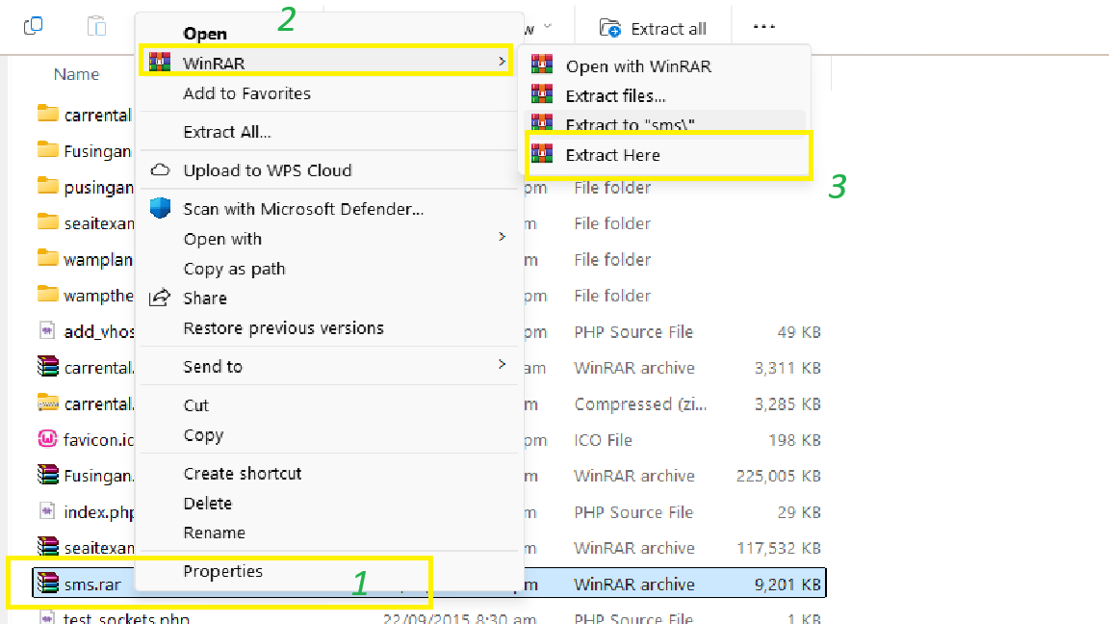
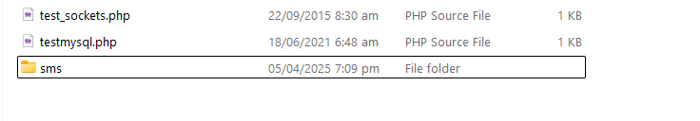
- After extract you get this folder:

- Open the sms folder then copy the app-release.apk in your android device not in ios device it won’t work:
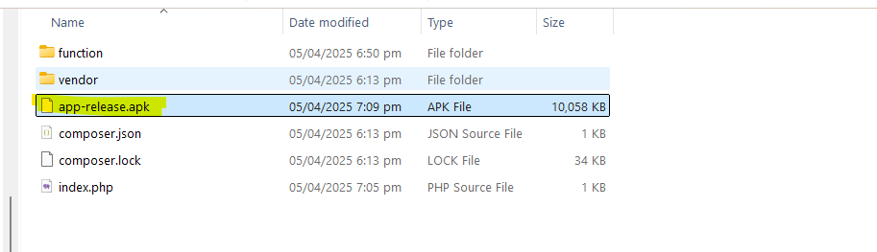

- HOW TO INSTALL THE APK:
- Follow this steps you can’t install the app if you didn’t follow the procedure:
- Go to playstore click your profile right upper part of your screen
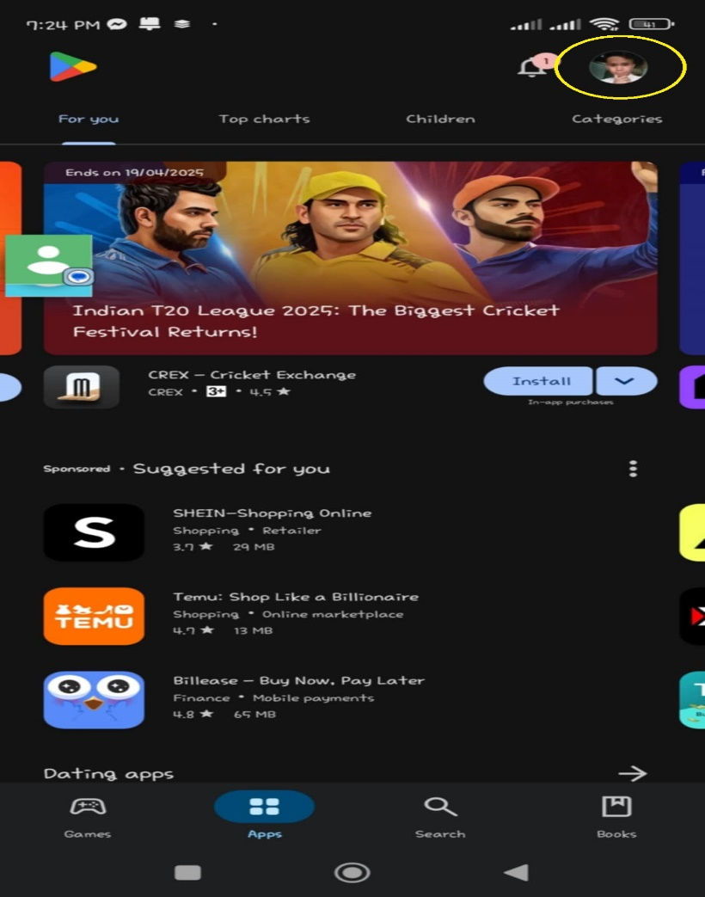

- Select the play protect
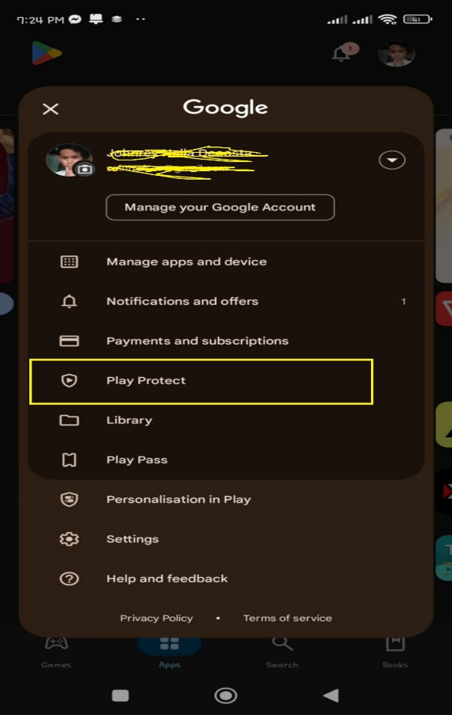

- Click the setting button in the right upper part of your screen:
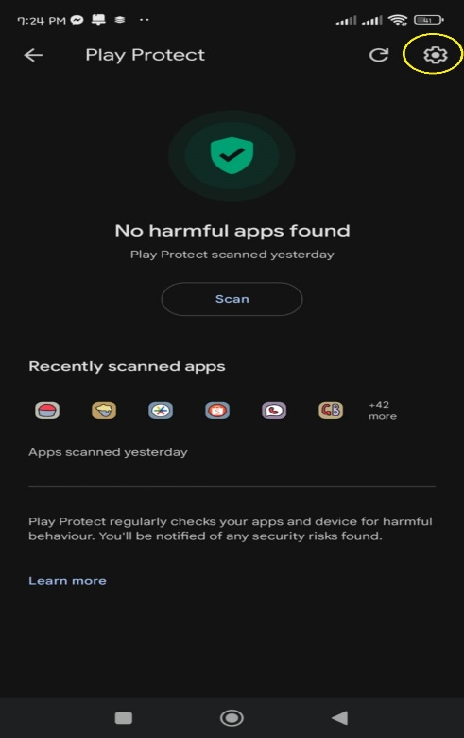

- Make sure you disable scan apps with play protect:
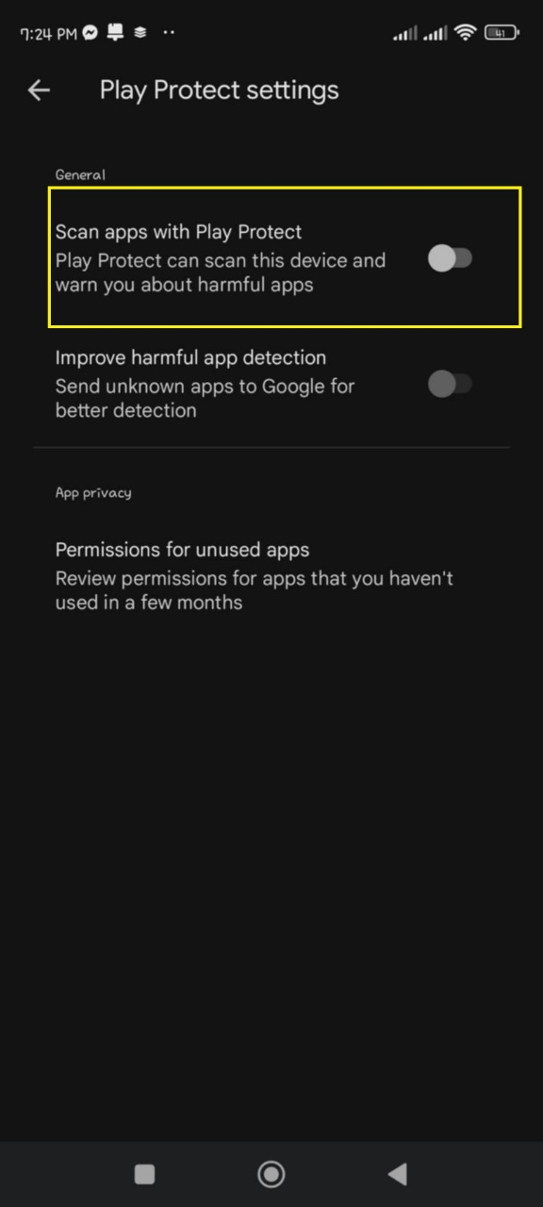

- Install the app-release.apk in your android device then allow all the permission

How to integrate?
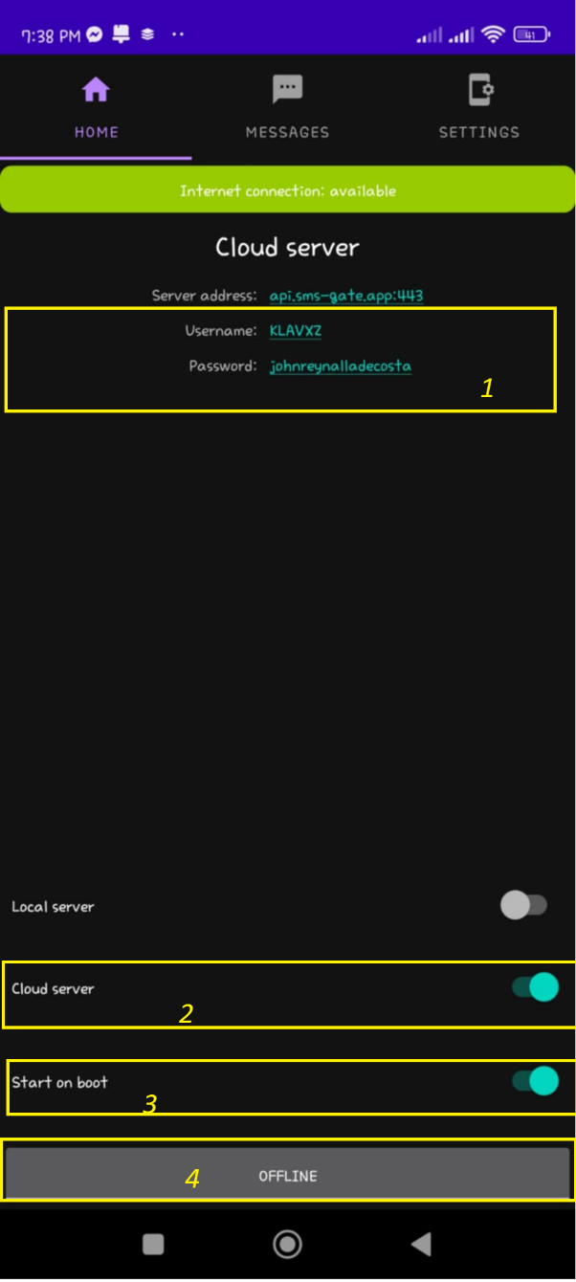
(Look the numbering and below is the explaination)
- Once you click the button in step 4 the app will auto generate an username and password for you. Save your username and password
- Make sure you toggle on the cloud server
- Toggle on the start on boot
- Click button to start the service

Optional
- If you want to change your cloud server password go to settings > cloud server > then click the password
Note : Username can’t be change

How to test if working?
- Open your wampserver
- Open the index.php in sms folder you extract earlier
- Look for the comment the you must edit the value of the username and password base on the credentials generated in the application
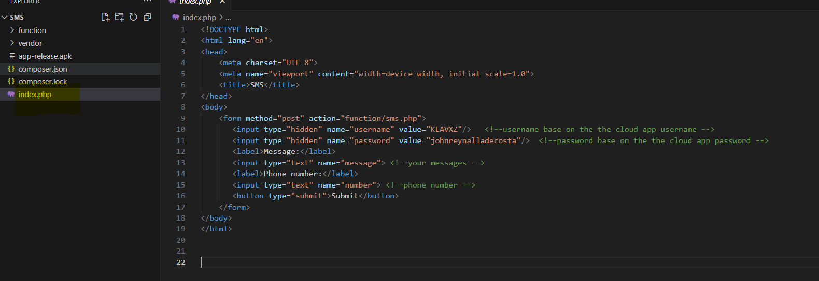
(Note if you didn’t change the username and password it wont work)
- Then try open localhost/sms
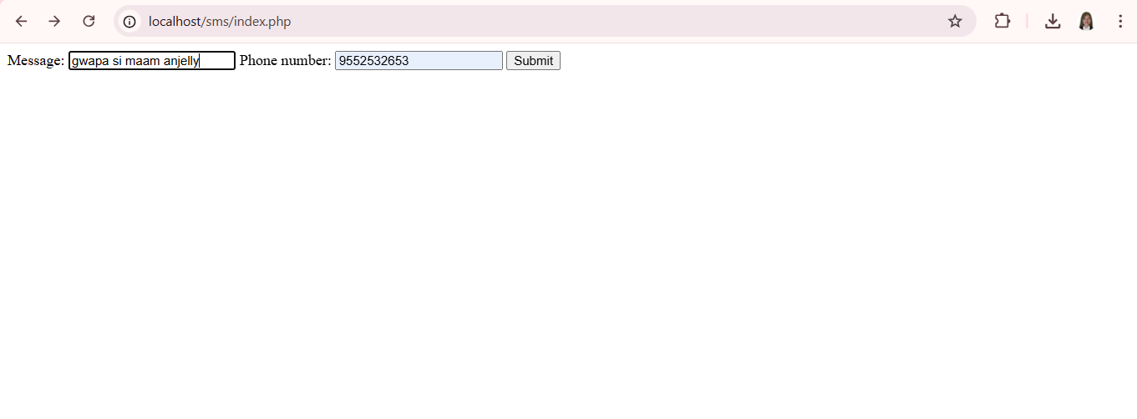

Note: Phone number starts on 9 ie. 9123456789
- Done
`

